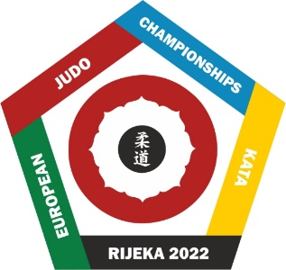
EUROPEAN JUDO CHAMPIONSHIPS KATA RIJEKA 2022

May 14th 2022 - 15th 2022, Rijeka, Croatia

VISA and BORDER APPLICATION FORM

FEDERATION:

VISA IS REQUIRED FROM TILL

WE WILL APPLY IN

(Country, City)

We kindly ask you to complete all columns in block letters.
№ | Surname | First name  (full as in passport) | Sex | Date of birth | Nationality | Passport number | Date of issue | Date of expiry | Arrival date | Arrival Time | Flight number | Border Name  (by car) or  / Airport name
1
2
3
4
5
6
7
8
9
10
11
12
13
14
15
16
17
18
19
20
21
22

Please be so kind and send back this document in word format, not pdf. No stamp required. This form should reach the Organizing Committee by April 10th 2022. Contact: orijana@rss.hr

