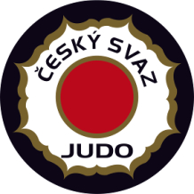
European Judo Open
Men & Women
Prague – Czech Republic
February 27-28, 2021
tel.: +420 -233 355 280
fax: +420 -257 214 265
E-mail: sejudo@cstv.cz

Visa Application Form

FEDERATION XXX Date, Stamp & Signature XXX
Our delegation needs the invitation from the XXX till the XXX 2021.
We will apply for visas at the Embassy in XXX (country, city).
Contact person of the delegation XXX (name, email, mobile phone)

First Name | Surname | Nationality | Date of Birth | Passport No | Date of issue | Date of expiry | Sex | Position in the delegation
(Doc/xls format only, NO PDF)

