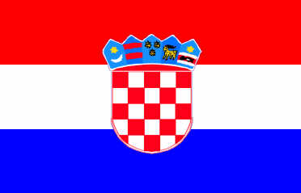 | EJU REFEREEING & COACHING SEMINAR 2011  20th-21 th May 2011 Dubrovnik / Croatia  Croatian Judo Federation  Tel: +385 1 3012 349 Fax. +385 1 3012 349  E-mail: sanja@dubrovniktravel.hr

VISA APPLICATION FORM

FEDERATION

We need the invitation from |  | till |  | May 2011
We will apply for visas in Croatian Embassy in |  |  | (Country, city)

We kindly ask you to complete all columns in block letters. Please be precise in order to produce the visas in time for your seminar participants.
To arrange visas we also need a copy of the first page of the passport (where the picture is) of each participant

№ | Name | First name | Position | Date of birth | Place of birth | Nationality | Passport number | Date of issue | Date of expiry
Date:

Signature:

