



EUROPEAN CUP JUNIOR MEN & WOMEN
KAUNAS, 07-08 MAY, 2011 & TRAINING CAMP KAUNAS, 09-12 MAY
age 15-19 (born in 1992-1996)

Date | May, 07 (Sat.) and 08 (Sun.), 2011
Venue | A.Sabonis Sport Hall  Pasiles g. 39a  Kaunas
Organizer | Lithuanian Judo Federation  3005 Kaunas, Ausros g. 42a  Tel +37068715951 / Fax +37037337243  E-mail: info@judo.lt; lolita.judo@gmail.com  Emergency Contact Number: +37068715951 (eng); +37064289686 (rus)
Accommodation | Official Hotels  Hotel Kaunas ****  Laisves al. 79  Kaunas  Teams do not staying in official hotels will pay € 50,-
Managing Body | Lithuanian Judo Federation
Competition | Competition will be carried out according to the EJU / IJF official rules using the double repechage system. Competition systems with low number of participants:  2 entries: better of 2 fights, if 1-1 the third match will decide. 3, 4, 5 entries: one pool competition system. 6 and more entries : quarter –final (last 8) repechage or double  repechage competition system.  Time of fights: 4 min. Golden Score: 2 min.  The white and blue judogi are obligatory in this competition.  Preliminaries: 3 mats (7m x 7m)  Semifinals: 2 mat (7m x 7m)  Finals – 1 mat (7m x 7m).  The top 4 competitors in each weight category according to the EJU Junior RL will be seeded. Only participants from EJU/IJF Member Federation are allowed to compete.
Saturday,  May 7 2011 | Weigh-in Hotel Kaunas ( May 7)  unofficial: 07:00 - 07:30; official 07:30 – 08:30 am:  Women –63, -70, -78, +78kg Men -55, -60, -66, -73kg  Preliminaries/Repechage: 10:30 h  Final block (Medal contest) 16:00 h
Sunday,  May 8 2011 | Weigh-in Hotel Kaunas (8 May)  unofficial: 07:00 - 07:30; official 07:30 – 08:30 am:  Women -44, -48, -52, -57 kg Men -81, -90, -100, +100 kg  Preliminaries/Repechage: 10:30 h  Final block (Medal contest) 15:00 h  There might occur changes in the schedule, regarding the starting time of the final block.
Referees | All teams (more than 6 sportsmen) must be accompanied by an IJF / Continental referee.
Referees meeting | May (Fri) 6, 2011 19:00 h  Hotel KAUNAS EJU / IJF Dress Code: Jacket suit with tie.

Technical meeting and Draw | May (Fri) 06, 2011 20:00 h  Hotel KAUNAS EJU / IJF Dress Code: Jacket suit with tie.
Financial conditions | Hotel KAUNAS****  Laisves al. 79  Kaunas  € 60 double room per person/per night (B&B)  € 80 single room per person/per night (B&B)  Price is per person/per night B&B (and lunch in the sport hall)

Entries | a) First entry National Federations are requested to inform the Lithuanian Judo  Federation whether they will participate in the tournament or  not by prescribed entry form not later than March 15, 2011 to lolita.judo@gmail.com  b) Final entry Each federation will have to send to the Lithuanian Judo Federation the very precise composition of its delegation (enclosed form) by April 20, 2011 to lolita.judo@gmail.com
Accreditation | Hotel KAUNAS May 06 (Fri.), 2011: 12:00 h - 19:00 h
Remarks | For teams from Europe: Please make sure that your team arrives prior to 17:00 h,  Friday, May 06, 2011 as no additional or any change of entries will be accepted after 18:00 h.
Transfer | Federations that reserve rooms in the official hotels of competition can make use of all transportation. They will be picked up at the Kaunas or Vilnius airport or train station and after competition transferred back to the airport or train station. Federations not staying in official hotels can’t use transportation.
Liability | Neither the organisers of the event, nor the Lithuanian Judo Federation (nor any of its officials or members) will be liable or responsible for any personal injury nor for any loss or damage to your property arising out of your participation and travelling in connection with this tournament. The Lithuanian Judo Federation declines all responsibility.
Judogi  Advertisement | Please observe the rules of the EJU as far as advertisement on the Judogi is concerned
Judogi Backnumbers | Please note, that blue and white judogis will be obligatory. Judogi control according to Sokuteiki rule. Judogi must be IJF approved.  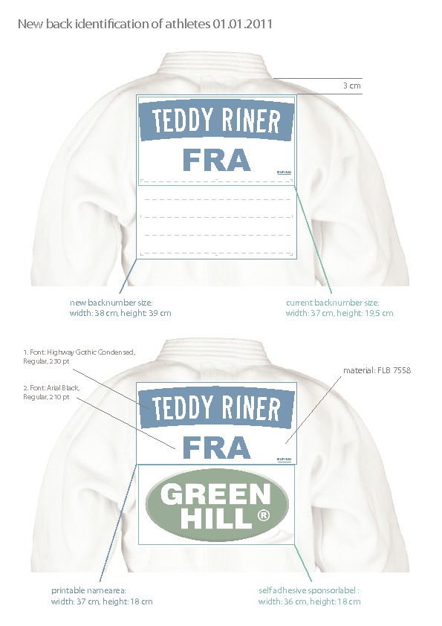
Inscriptions | Transport schedule and hotel reservations before the 20 of April  The nominal entry before the 15 of March  In order for an athlete to obtain points for the EJU Ranking List, his / her weight category should have participants from at least 2 different countries. If this is not the case, the competition can still be held, according to the organiser’s decision.  If, by the Nominal deadline, there are less than 2 countries inscribed in any weight category, the organizer is obliged to inform immediately the NF concerned.
Visa | For nations, who need VISA to enter Lithuania, please send us as soon as possible (latest 1st April 2009) the list of participants with names, passport numbers, nationality, birth dates+place, address and function. Information about visas for your country you can find at: http://www.urm.lt
TRAINING CAMP | The Training Camp following the tournament will be organised  in Kaunas A.Sabonis Sport Hall from 09 – 12 May 2011.

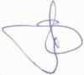
President Vigmantas Sinkevicius

