 | JUNIOR EUROPEAN CUP  23-24 APRIL 2011, SAINT PETERSBURG, RUSSIA  TOP RANKING | 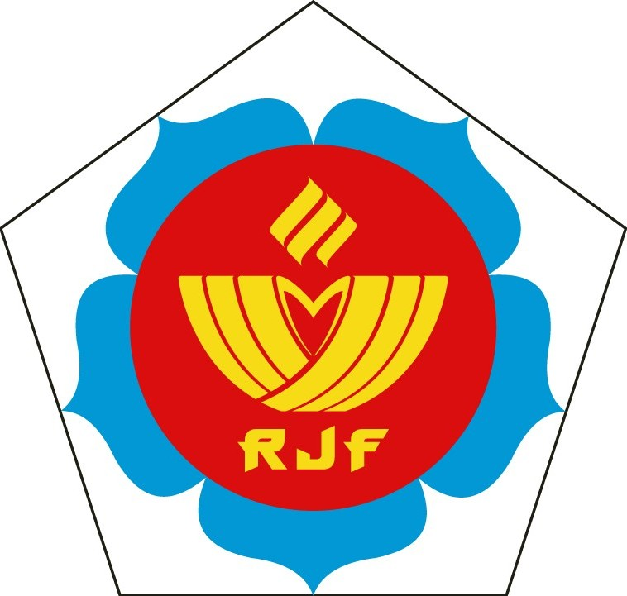

FIRST ENTRY

Federation:

 | TOURNAMENT | TRAINING CAMP
NUMBER OF
PARTICIPANTS
NUMBER OF
OFFICIALS

Date :

Name of contact person:

Please return this form before 26 February 2011 to the Russian Judo Federation

JUNIOR EUROPEAN CUP
23-24 APRIL 2011, SAINT PETERSBURG, RUSSIA
TOP RANKING

HOTEL RESERVATION FORM

Federation:

Hotel | Room type | Date  of  Arrival | Date  of  Departure | Number of persons | Number of nights | Total amount  €
 | single
 | single
 | single
 | single
 | single
 | double
 | double
 | double
 | double
Total:

Date: Stamp

Please return this form before 21 March 2011 to the Russian Judo Federation
JUNIOR EUROPEAN CUP
23-24 APRIL 2011, SAINT PETERSBURG, RUSSIA
TOP RANKING

FINAL ENTRY BOYS

Federation:
Official(s):
Referee(s):
Coach(es):

PARTICIPANTS:
weight  category | first name | name | best result
-55 kg
-55 kg
-60 kg
-60 kg
-66 kg
-66 kg
-73 kg
-73 kg
-81 kg
-81 kg
- 90 kg
-90 kg
-100 kg
-100kg
+ 100 kg
+100 kg

Date: Stamp:

Please return this form till 11April 2011 to the Russian Judo Federation
JUNIOR EUROPEAN CUP
23-24 APRIL 2011, SAINT PETERSBURG, RUSSIA
TOP RANKING

FINAL ENTRY GIRLS

Federation:
Official(s):
Referee(s):
Coach(es):

PARTICIPANTS:
weight  category | first name | name | best result
- 44kg
- 44kg
- 48 kg
-48 kg
-52 kg
-52 kg
-57 kg
-57 kg
-63 kg
-63 kg
-70 kg
-70 kg
-78 kg
-78 kg
+ 78 kg
+ 78 kg

Date: Stamp:

Please return this form till 11 April 2011 to the Russian Judo Federation
JUNIOR EUROPEAN CUP
23-24 APRIL 2011, SAINT PETERSBURG, RUSSIA
TOP RANKING

TRANSPORT FORM

Transport from/to airport/railway station and between hotel – sport hall is included in the accommodation fee.

Federation:

Date of arrival | Time of arrival | Flight / Train number | Airport/railway station | Number of persons

Date of departure | Time of departure | Flight / Train number | Airport/railway station | Number of persons

Date: Stamp:

Please return this form before 11 April 2011 to the Russian Judo Federation

