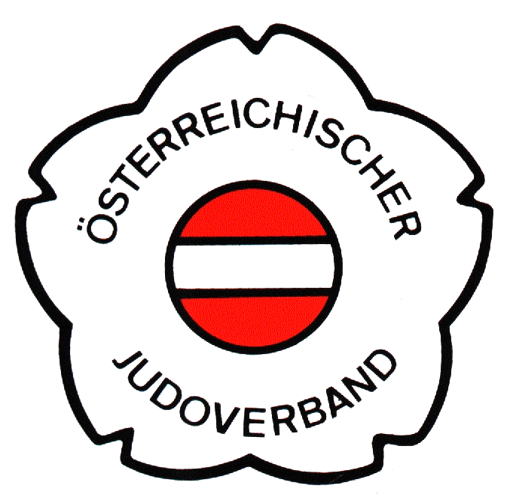

EJU Trainingcamp

Mittersill - Austria
8th – 14th of January, 2010

ENTRY FORM
Please fill in with capital letters and return until latest 5th of December, 2009.

Federation/Club

Adress
(please include E-Mail and telephone number)
Number of participants (total)
Officials
Female athletes
Male athletes

Hotel Category
A |  | B |  |  | C
Bed & Breakfast |  | Half Board |  |  | Full Board
Single Room (requested number) |  | Only available in category A!

Travel Information
Transfer requested |  | yes |  | no
ARRIVAL |  |  | DEPARTURE
Date of arrival |  |  | Date of departure
Flughafen/station |  |  | airport/station
Arrival time/Flight nr. |  |  | Arrival time/Flight nr.
from |  |  | to

Date | Stamp | Signature

EJU Trainingcamp

Mittersill - Austria
8th – 14th of January, 2010

FINAL ENTRY
Please fill in with capital letters and return until latest 10th of December, 2009.
NATION
Last name | First name | Funktion

Date | Stamp | Signature

