 | BAKU  WORLD CUP  MEN | 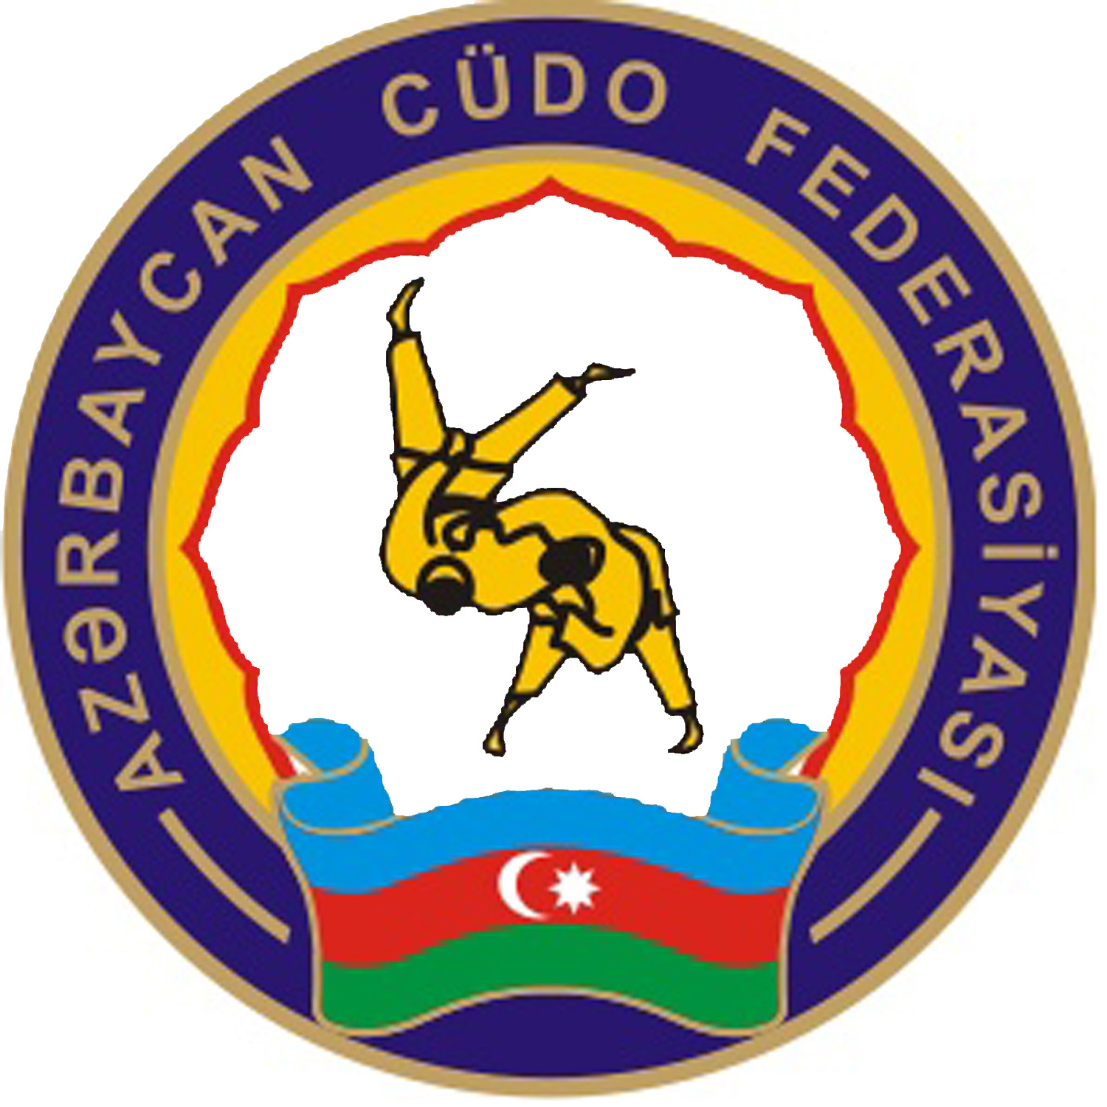
 | 10th & 11th OCTOBER 2009

FIRST ENTRY FORM

FEDERATION
TELEPHONE / FAX
E-MAIL
CONTACT NAME

Our federation will take part in Baku World Cup Men

Our federation will not take part in Baku World Cup Men

Function | Number

Athletes

Coaches

Referees

Other

TOTAL

Please fill in the number in each category.

60kg | 66kg | 73kg | 81kg | 90kg | 100kg | +100kg

Yes, we will accommodate in one of the Official Hotels:
No, we will not accommodate in one of the Official Hotels:

Date: Signature: Federation Stamp:

RETURN TO THE AZERBAIJAN JUDO FEDERATION:
FAX | +994 12 465 64 38
Email | judo@mys.gov.az
BEFORE: 7 August 2009
BAKU
WORLD CUP
MEN
10th & 11th OCTOBER 2009

FINAL ENTRY FORM (MEN)
FEDERATION
TELEPHONE / FAX
E-MAIL
CONTACT NAME

Weight category | Family name | First Name | Date of birth | Best result
- 60 kg
- 66 kg
- 73 kg
- 81 kg
- 90 kg
- 100 kg
+100 kg

Date: Signature: Federation Stamp:
RETURN TO THE AZERBAIJAN JUDO FEDERATION:
FAX | +994 12 465 64 38
Email | judo@mys.gov.az
BEFORE: 14 September 2009

BAKU
WORLD CUP
MEN
10th & 11th OCTOBER 2009

REFEREES & OFFICIALS ENTRY FORM

FEDERATION
TELEPHONE / FAX
E-MAIL
CONTACT NAME

REFEREES

Surname | First name | Qualification

OFFICIALS

Surname | First name | Function

Date: Signature: Federation Stamp:

RETURN TO THE AZERBAIJAN JUDO FEDERATION:
FAX | +994 12 465 64 38
Email | judo@mys.gov.az
BEFORE: 14 September 2008
BAKU
WORLD CUP
MEN
10th & 11th OCTOBER 2009

HOTEL RESERVATION FORM

FEDERATION
TELEPHONE / FAX
E-MAIL
CONTACT NAME

HOTEL

Room type | Arrival date | Departure date | Number of persons | Number of nights | Total amount, Euro
Single
Single
Double
Double
Double
Total persons |  |  |  | Total Cost, Euro

Date: Signature: Federation Stamp:

RETURN TO THE AZERBAIJAN JUDO FEDERATION:
FAX | +994 12 465 64 38
Email | judo@mys.gov.az
BEFORE: 26 September 2009
BAKU
WORLD CUP
MEN
10th & 11th OCTOBER 2009

TRAVEL SCHEDULE

FEDERATION

ARRIVAL:

PLANE/TRAIN
Date | Arrival Time | Flight Number | From | Airport/ railway station | Number of Persons

DEPARTURE:

PLANE/TRAIN
Date | Departure Time | Flight Number | Destination | Airport/ railway station | Number of Persons

Any changes to travel arrangements must be sent at least 10 days prior to arrival in Baku to ensure transfers to official hotel.

Date: Signature: Federation Stamp:

RETURN TO THE AZERBAIJAN JUDO FEDERATION:
FAX | +994 12 465 64 38
Email | judo@mys.gov.az
BEFORE: 01 October 2009

